## 附录3.2 静态工作点的仿真求解

如图Figure 1所示，当 $i_{c}$ 为2.5000mA时，UC=9.001V、UE=2.700V、UB=3.411V、UCE=6.231V，此时RB2=67.18KΩ

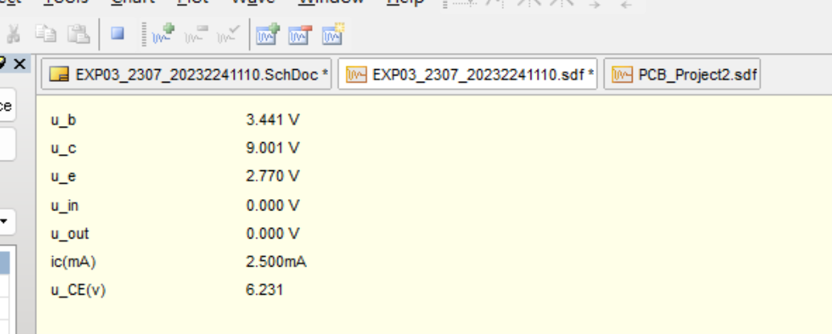

Figure 1

仿真得到下面7组数据，导入matlab进行最小二乘法拟合曲线，得到图Figure 2，拟合性能如图Figure 3所示

Table 1

|  |  |  |
| --- | --- | --- |
| Rw | ic（mA) | u_CE(V) |
| 0.1000 | 1.3350 | 10.3200 |
| 0.3000 | 1.6820 | 9.1090 |
| 0.5000 | 2.1810 | 7.3540 |
| 0.5930 | 2.5000 | 6.2310 |
| 0.7000 | 2.9760 | 4.5610 |
| 0.8000 | 3.5790 | 2.4450 |
| 0.9000 | 4.2360 | 0.1060 |

|  |  |
| --- | --- |
|  |  |
| Figure 2 | Figure 3 |